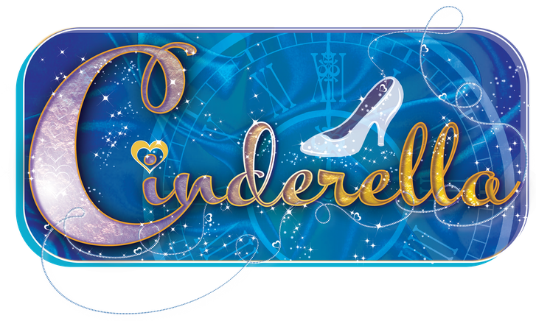

AUDITION FORM

PERSONAL DETAILS
NAME

ADDRESS
(including Postcode)
DAY TELEPHONE

EVENING TELEPHONE
MOBILE TELEPHONE
EMAIL ADDRESS
AGE |  |  | HEIGHT  In Feet and Inches please | Ft | In

PREVIOUS EXPERIENCE
SHOW (AND DATE) | ROLE | COMPANY

I WOULD LIKE TO AUDITION FOR THE FOLLOWING PRINCIPAL ROLE(S):

I WOULD ALSO LIKE TO BE CONSIDERED FOR THE FOLLOWING PRINCIPAL ROLE(S):

IF THE AUDITION PANEL CONSIDER YOU SUITABLE FOR AN ALTERNATIVE ROLE ARE YOU HAPPY TO BE CAST? YES / NO (Please delete as applicable)

IF NOT CAST IN A PRINCIPAL ROLE ARE YOU WILLING TO JOIN THE ENSEMBLE AND/OR BE CONSIDERED FOR AN UNDERSTUDY POSITION? (Please tick the appropriate box)

Willing to join the Ensemble Only:

Willing to join the Ensemble and be
considered for an Understudy position: appropriate)

Not willing to join the Ensemble: appropriate)

Do you have any other talents we don’t know about that we could potentially use in the show? Are you a musician, an acrobat, a juggler, a magician etc? Please let us know.

Any other information which may be useful when arranging audition times:
eg. I am only available in the morning.

Any dates when you will not be available during the rehearsal period: (please only list dates that effect our rehearsals)
eg. I am not available on any Wednesday evening for rehearsal.

PLEASE RETURN THIS COMPLETED FORM VIA EMAIL OR POST TO:

MKAOS
PO Box 1618, Northampton, NN2 1HN
kevin@dreamsnwishes.co.uk

By midnight – Friday 3rd September 2021
You will then be advised of your audition time
You will not be able to audition if you have not sent in a completed audition form in advance
If you audition for or agree to be considered for a part,
the panel will assume that you accept the part if you are cast.

